

WESTERN RANGES
PRIMARY DIVISION

SWIMMING CHAMPIONSHIPS
2025

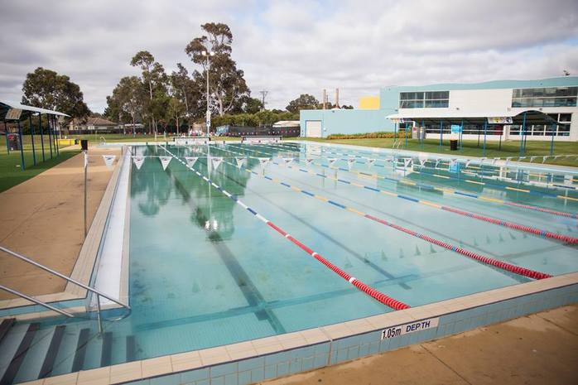
Competing Districts | Details
*Marshalling  *Timers  *Results *Speaker/Presentation | MELTON WAVES OUTDOOR POOL  (206 Coburns Rd, Melton VIC 3337)  TUESDAY 11th MARCH, 2025  COMMENCING 10.00am
  MACEDON RANGES | POOL | MELTON 1
  BACCHUS MARSH | POOL | MELTON 2
WESTERN RANGES DIVISION COORDINATOR:
Ian Shattock (Melton CC) ishattock@mcc.vic.edu.au

Schedule of Competition
AGE GROUP ORDER: 9/10 > 11 > 12/13 > Multiclass (Girls then Boys)
9:30-9-50 | Warm Up Swim (this is not a free swim)
Start: 10am | - 50m Freestyle  - 50m Breaststroke
 | 3. Presentations for Freestyle and Breaststroke
4. 50m Backstroke
5. 50m Butterfly
 | 6. Presentations for Backstroke and Butterfly
Lunch
Relays | All relays will begin at the shallow end of the pool (no dive)  Order: Medley relays then Freestyle relays  - 4 x 50m (200m) Girls Medley  - 4 x 50m (200m) Boys/Mixed Relay  - 4 x 50m (200m) 9/10 Girls Freestyle Relay  - 4 x 50m (200m) 9/10 Boys/Mixed Freestyle Relay  - 4 x 50m (200m) 11 Girls Freestyle Relay  - 4 x 50m (200m) 11 Boys/Mixed Freestyle Relay  - 4 x 50m (200m) 12/13 Girls Freestyle Relay  - 4 x 50m (200m) 12/13 Boys/Mixed Freestyle Relay  ORDER FOR 4 x 50m (200m) MEDLEY (Girls then Boys/Mixed)  BACKSTROKE / BREASTSTROKE / BUTTERFLY / FREESTYLE
Relay presentations and wrap up
Free swim (if time allows)
Swimming Trials will be completed by approximately 1:30pm

individual events: lanes
LANE | 1 | 2 | 3 | 4 | 5 | 6 | 7 | 8
Relays | bacchus marsh | bacchus marsh | macedon ranges | macedon ranges | melton 1 | melton 1 | melton 2 | melton 2

relay lanes
(Swimmer 1 and 3 to be walked to shallow end of pool. relays start at shallow end)
LANE | 1 | 2 | 3 | 4 | 5 | 6 | 7 | 8
Relays |  |  | bacchus marsh | macedon ranges | melton 1 | melton 2

NEXT LEVEL: WESTERN METROPOLITAN REGION SWIMMING CHAMPIONSHIPS
TUESDAY 1st April at THE KARDINIA AQUATIC CENTRE (Park Lane, South Geelong , 3220)
INDIVIDUAL EVENTS: Competitors need to finish 1st or 2nd in their race to progress.
RELAY EVENTS: Teams need to finish 1st to progress.
NOTE: This meet will be conducted under Swimming Victoria guidelines along with policies and procedures of School Sport Victoria. Swimming Victoria officials will be in attendance on the day.

Competition Rules
Link to SSV Swimming Rules of Competition: https://www.ssv.vic.edu.au/state/Documents/RulesSwimmingPrimaryandSecondary.pdf
PLEASE NOTE:
Entry of Events
- Ages are calculated as of December 31st, 2025. Whichever age you turn in 2025 is the age group you will be competing in.
- Each DISTRICT may nominate two competitors for each individual event and one team for each relay event.
- A child is permitted to enter a maximum of two individual events, one freestyle relay and one Open Medley Relay.
- No child may enter the same event in two different age groups.
- A child must have competed at district level to compete at division. No invitationals allowed.
Progression
- The 1st and 2nd place finishers from all individual Division Finals and the 1st placed team for all relay finals will proceed to the Western Metropolitan Regional Swimming Championships (date and venue above).
- This meet will be conducted under Swimming Victoria guidelines along with policies and procedures of School Sport Victoria. Swimming Victoria officials will be in attendance on the day.
- Swimming Victoria officials will have the final say when it comes to competitors' technique and disqualifications. Competitors who DO NOT show the correct technique will be disqualified (DQ) at Division level.
General
- First Aid: All schools are to provide their own First Aid needs, support will be provided if needed.
- Children are asked to stay in their district’s swimming area behind the concrete while not swimming. No swimming in the indoor pool unless supervised by their parent.
- We kindly ask that individuals stay off the concreted area surrounding the pool.
- We appreciate your positivity towards the staff and volunteers who allow this day to occur.
Photography
- Video and photographs are not allowed in the field of play, being the pool.

Photography: | Photography taken by spectators is permitted away from the area of competition.  During SSV sporting events, SSV staff may photograph, film or record students participating in SSV activities or events. We do this for many reasons including to celebrate student participation and achievement, communicate with our parents and school community and to promote SSV events on the SSV website and other social and digital media accounts. It is the responsibility of the parent/carer and/or schools to inform SSV and/or the photographer which students should not be photographed. This can occur before an event or during an event. To opt-out of photography during an event please inform SSV staff and photographers at the event. Please see privacy policy for more details: https://www.ssv.vic.edu.au/Downloads%20Library/Privacy%20Policy.pdf
Accident/  Incident Report | From time to time while conducting sporting events incidents may occur including:  : • Personal Conflict • Discipline Issues • Accidents involving staff and students  The convener of an event will investigate these incidents and send a report to the principal of the schools involved and relevant School Sport Officer or the Executive Officer of SSV.  Accident Incident Report Form  Guidelines to support with dealing with accidents/ incidents promptly and effectively: Accident and Incident Report Procedure

- School Sports Victoria will take photos of the presentation of ribbons. If you do not want your child/student to have their photo taken please notify the convenor prior to the event.

Melton Waves
- Entry - Any spectators will need to pay the spectator fee upon arrival at reception
- Everyone is to enter Melton Waves via the Main Entrance.
- We appreciate the use of the surrounding bins for all rubbish.
- No Running allowed.
- Alcohol and Smoking– No alcohol and smoking is permitted within the facility.
- Please see the emergency evacuation plan on the last page of this booklet.
- Only EFTPOS available at the CAFÉ at Melton Waves (no cash)

For any further enquiries please contact Ian Shattock (see details on front page)

SSV PRIVACY STATEMENT
“The Information Privacy Act 2000 requires the School Sport Victoria to inform you that, in the conduct of school sport, photographs may be taken of participants and results compiled to record student participation, celebrate student success and achievement and to promote the SSV and events conducted by the SSV. We limit the use and disclosure of any personal information to the purpose of participating in school sport. By accepting the invitation to participate in events under the auspices of the SSV, you undertake to abide by the SSV Privacy Policy.” SSV officials will not divulge personal information about students who participate in SSV activities. (This includes parent details, address, phone number, school details or phone, medical information, etc.) Personal information about any student will be destroyed once that student has completed their involvement in the particular activity for which the information was obtained.

ROLES & RESPONSIBILITIES
All helpers are to report to Ian Shattock on arrival (9:30am).
Convener and Announcer | Ian Shattock
Responsibility: Assist with Marshalling, introduce events, general announcements, ensure events are on time
Chief Marshall: | Jordan Patty MPSSA 1 (2 student helpers to help with event board)
Marshall Assistant/False Start Rope | Macedon Ranges
Responsibility: Oversee marshalling of all competitors, including relays and communicate with announcer re the calling of events for marshalling
Starter and Chief Judge: | Ray McColl and Ken Linder- Swimming Victoria
Responsibility: To start races and assess children’s stroke technique to ensure correctness
Time Keeper | Trent Waring MPSSA1
1 person with an electronic timer to time all lanes and then walk results to the results table.
Relay Changeover/ Finish Line Judges: | Garrick Demarchi (MPSSA 2) and Ian Shattock
Responsibility: Identifying finishing order and directing all students to the results table.
1st-3rd Place Pegs | 3 x MCC students
iPad Video of finish line | 1x MCC student
Results | Dave Champness (BMPSSA)
Responsibility: Recording results, entering times from electronic docket, updating information as required
Presentation- Ribbons & Region Information: | District Coordinators and Secondary Students
Responsibility: assisting with results information handing out ribbons and region information to swimmers
School Sports Victoria will take photos of the presentation of ribbons. If you do not want your child/student to have their photo taken please notify the convenor prior to the event.
